
 | SD 1: Display Customer Master Record
Exercise Use the SAP Easy Access Menu to display a customer. Time 10 min
Task Global Bike Inc. has numerous customers both in the US and in Germany. Display one customer for the US (Philly Bikes) and one for Germany (NeckaRad).
Name (Position) Maria Diaz (Sales Person 1)
In order to create a sales order, follow the SAP Easy Access menu path:  Logistics ► Sales and Distribution ► Master Data ► Business Partner ► Customer ► Display ► Complete |  | Menu path
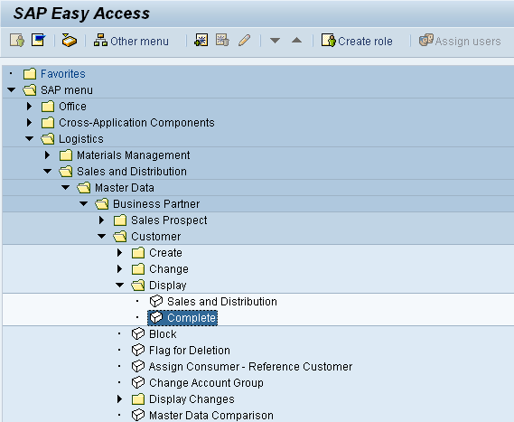
Expand the menu path, then double-click on Complete.
On the next screen, the SAP system expects you to enter search criteria such as the customer, the company and sales area data. You can use the SAP ad-hoc help to have the system explain particular fields on the screen. Positions your cursor in the Customer field and press F1. |  | F1
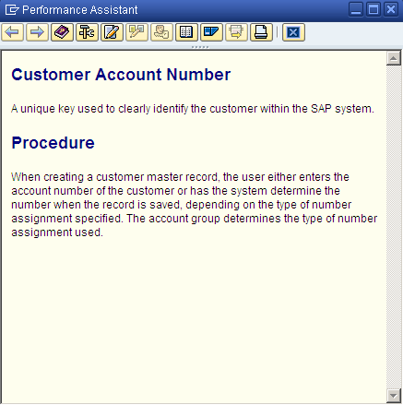
According to the SAP definition, in the Customer field, SAP expects you to put in the unique key identifying the customer master record. |  | Customer
Click on the button in the upper right corner of the screen to close the window.
As you do not know any customer number in the GBI company, you need to find them. In order to do so, position your cursor in the Customer field again and press F4. |  | F4
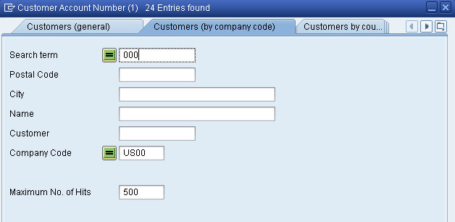
Tabs allow you to specify different search criteria. Values in the text boxes are used to filter the search. On the Customers (by company code) tab, you may enter any information you know of a customer you are looking for. In our case, in the Search term field, enter the three-digit number (###) that was given to you by your instructor. |  | ###
Note Every time the curriculum material requests you to type in ###, please enter the three-digit number assigned to you for this class. As each student has its own set of data, this number is used to distinguish between individual data sets. Please remember that all participants are working in the same GBI company and if not setting their search criteria as requested could see all master data (as in a real company). As for customer master records, if you would like to see once all 1000 copies of each customer, you can leave the Search term field blank.
After you have entered your number (###) in the Search term field, position your cursor in the Company Code field and press F4. In the following screen double-click on Global Bike Inc. in Dallas to select this company. After doing so, the Company Code field should be populated with US00.  Then, click on or press Enter. This will produce the following screen. Remember that the customer numbers could be different on your result screen. |  | F4  US00
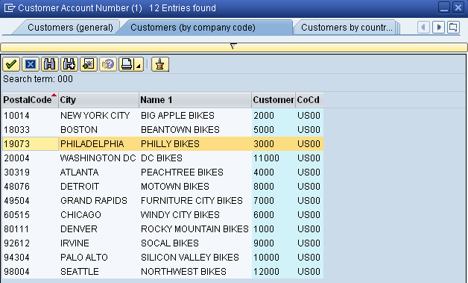
You can select Philly Bikes by double-clicking on it. When you do, the search result window will close, and the customer number for your number (###) of the Philly Bikes will be entered in the Customer field. In addition, the system will automatically fill in the Company Code field with US00. Again, note that your customer number might be different than the one in the screen below. |  | Philly Bikes
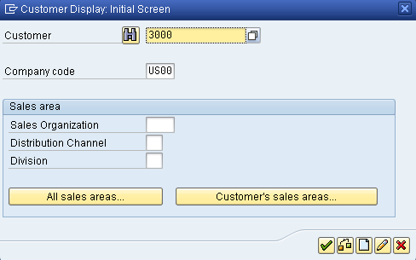
Now, click on or press Enter to display the customer master record stored for Philly Bikes. This will produce the following screen.
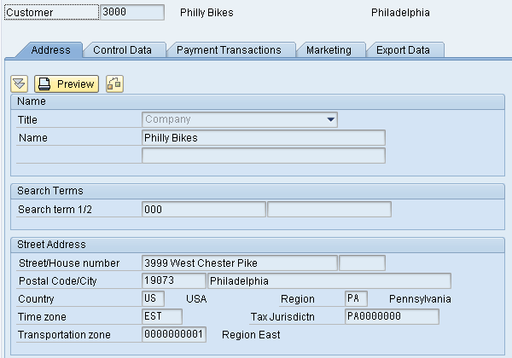
On this screen, you can see the general data of your Philly Bikes customer. In SAP, this means all information of this customer that is relevant to the entire GBI concern (US and Germany) such as global name and address. You can click on the other tabs to see other global data stored for Philly Bikes.
In order to display US-specific data, click on the Company Code Data button.
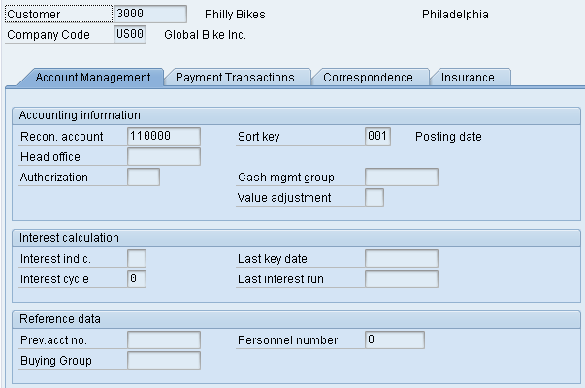
Note that the company code number (US00) has been added to the screen. Data such as Reconciliation account or Sort key are company code-specific data and different values could be entered for other company codes, e.g. DE00 (Germany).
In order to continue with your second task (display NeckaRad customer in Germany) click on to go back to the Initial Screen.
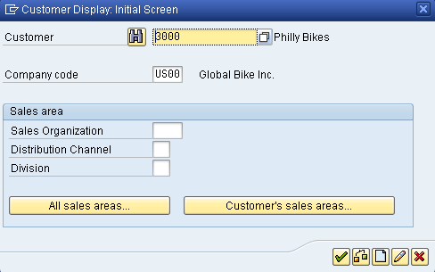
In order to find the customer number, position your cursor in the Customer field and press F4 again. On the following screen, make sure that you are on the Customers (by company code) tab. Again, position your cursor in the Company Code field and press F4. Then, select Global Bike Germany GmbH (DE00).  After the system has populated DE00 in the Company Code field, enter your number (###) in the Search term field again and click on . This will produce a list of all German customers (in your data set). |  | F4  F4  DE00  ###
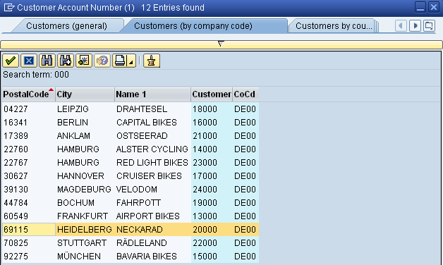
Double-click on the NeckaRad line to select this customer (with its number). Remember that your customer number might be different again. |  | NeckaRad
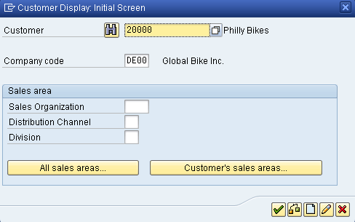
Note that the system does not only copy the customer number, but also the Company code which is now Germany (DE00). Click on and discover both the general and the company code data for NeckaRad.
After you are done, click on the exit icon to return to the SAP Easy Access Menu.

 | SD 2: Create Sales Order
Exercise Use the SAP Easy Access Menu to create a sales order. Time 15 min
Task Create a sales order for five black Deluxe Touring Bikes to the Philly Bikes Company to start the sales order process.
Name (Position) David Lopez (East Rep. Miami)
In order to create a sales order, follow the SAP Easy Access menu path:  Logistics ► Sales and Distribution ► Sales ► Order ► Create |  | Menu path
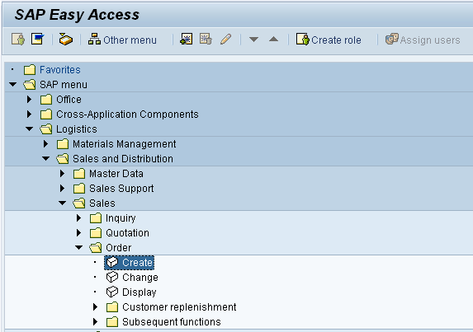
Expand the menu path, then double-click on Create.
Enter OR for Order Type (Standard Order), UE00 for Sales Organization (US East), WH for Distribution Channel (Wholesale), and BI for Division (Bicycles). Then click on or press Enter. |  | OR  UE00  WH  BI
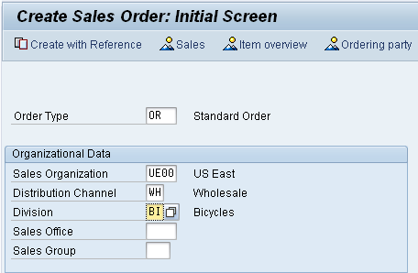
Order type OR is a standard sales order. Other order types can be implemented, like cash sale, rush order, consignment sale, etc. The Sales Organization, Distribution Channel and Division define the Sales Area, which will determines many of the terms of this sale like pricing. |  | Order type  Sales Area
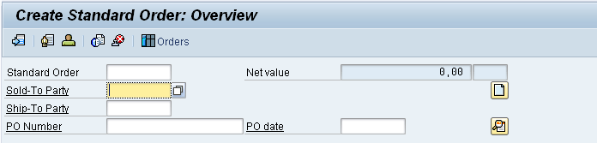
First, we need to enter the customer number for the Sold-to party. In order to look up the customer number again, use the search capability to find customer Philly Bikes. Click on the Sold-to party text box, then press F4, which will produce the following pop-up window: |  | Sold-to party  F4
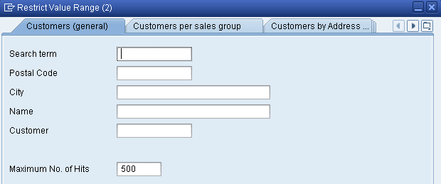
On the Customers (general) tab, in the Search term field put your individual number (###) assigned by your instructor. After clicking on , you will get a list of customers that meet the search criteria. This time, you will see the complete list of GBI customers for number (###) both in the US and in Germany. |  | ###
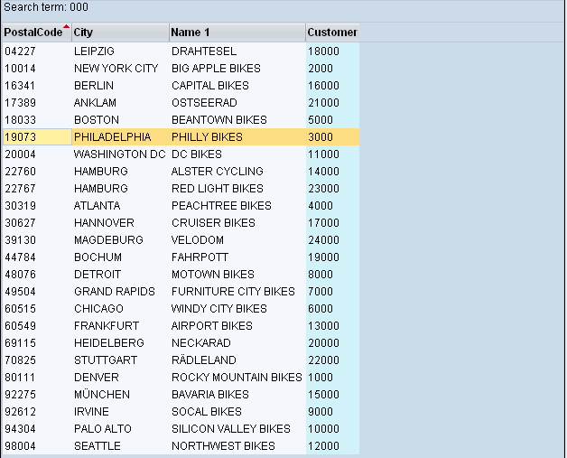
You can sort the result list by clicking on the column names, e.g. on Customer to sort the list by customer number. Then, select Philly Bikes by double-clicking on it. When you do, the search result window will close, and the customer number for your number (###) of the Philly Bikes will be entered in the Sold-to party text box. Please note that your customer number might be different than the one in the screen below. |  | Philly Bikes
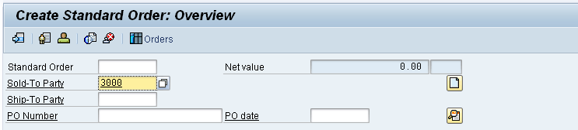
Next, you must enter the PO (purchase order) number for this transaction. The PO number is supplied by the customer and is the number the customer’s purchasing department uses to track this transaction. When we save this sales order, the SAP system will assign a sales order number to this transaction, which is the number we (the supplier) will use to track this transaction. We enter the PO number supplied by the customer in this sales order screen so that we can reference this document by the customer’s PO number. Please enter your individual number (###). |  | PO number  ###
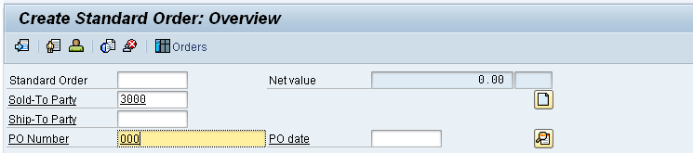
Next, we need to enter the PO date. We want to enter today’s date, and rather than typing in the date, we can use the search capability to simplify this task. First, click in the PO Date field, then press the F4 key. This will produce the pop-up calendar window shown below. |  | PO date  F4
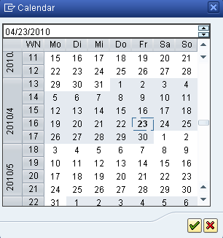
Here, you can select any date. For this exercise please simply press Enter, which selects the current date and enters it into the PO date field.
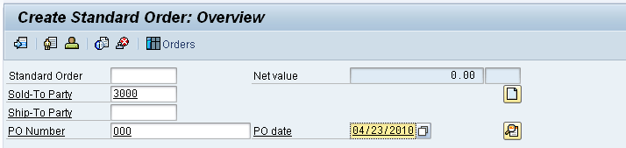
Next, we want to set the customer’s required delivery date to three days from now. To do this, click on the Req. deliv.date field, then press the F4 key. This will again produce the calendar pop-up window. |  | F4
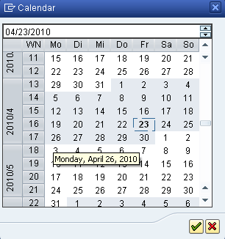
Today’s date is indicated by a box. Double-click on the date three days from today to select it.  Now we need to specify that this customer wants to buy the Deluxe Touring Bike in black. For the sales order form, we need the material number for this product, and the search capability will allow us to find this number easily. First, click on the first Material field, then click press F4. The following screen will appear. |  | three days from today  F4
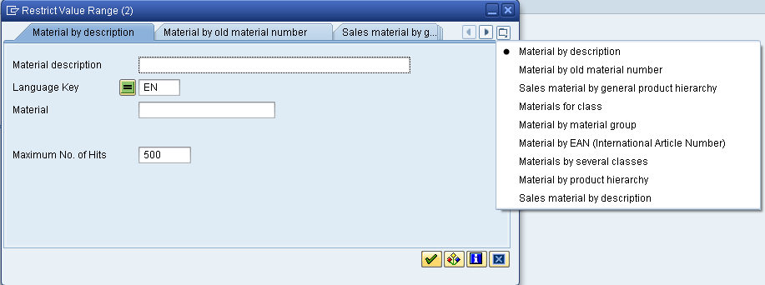
To easily get a list of bikes that we can sell, we can use the Sales Material by description tab. We can get a list of the search tabs by clicking on the icon to get a list of tabs (shown above), then selecting Sales material by description.
If not already defaulted by the system, enter Sales Organization UE00 and Distribution channel WH. As you only would like to see the sales goods for your number, enter *### in the Material text box. So, if your number is 005, enter *005. Please compare to the screen shown below and note that your material search criterion differs. |  | UE00  WH  *##
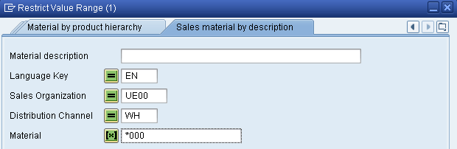
Then, click on . The system will produce a list of bikes ending with your number that GBI sells in the US East sales organization through Wholesale.
In the list, you can see that in addition to bicycles (finished goods) GBI sells trading goods such as t-shirts or pads to its customers. For this task, double-click on the black Deluxe Touring bike to select it. The material number for this bike (DXTR1###) is entered. Again, your material number will differ from the one in the screen below. |  | DXTR1###
Next, click on the Order Quantity text box, enter 5, then click on . This will cause the SAP system to check the data we have entered and call up additional data from the database. First, we will get an information message. |  | 5
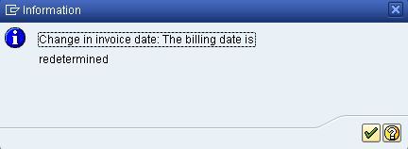
After clicking on , we will get additional data on the sales order screen.
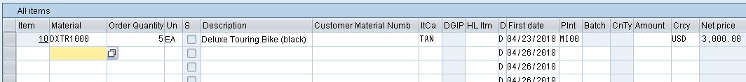
A significant amount of data retrieval and calculation has occurred:  - Customer address data is now presented  - The price for this order has been calculated  - The total shipping weight has been calculated  - The description of the bike is now presented  After selecting (high-lighting) the line with the Deluxe Touring bike, click on the pricing icon . |  | Pricing
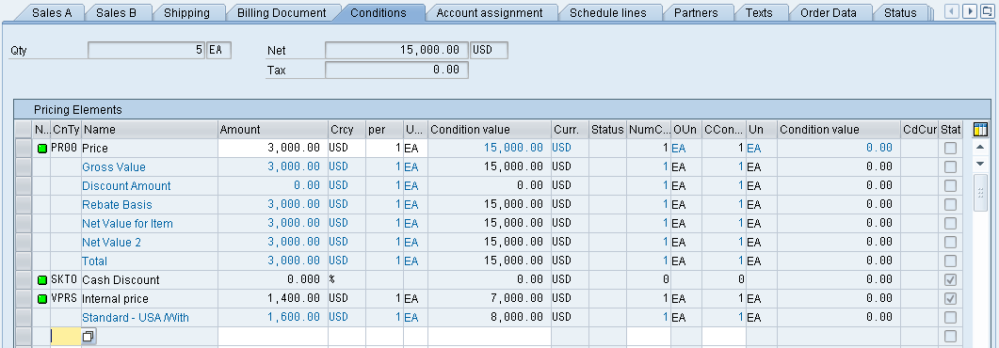
This screen shows that each bike costs $3,000, and no discounts or surcharges have been applied. It also shows that GBI should make $1,600 profit per bike sold. Click on the back icon to return to the sales order screen. Click on the save icon to save the sales order.
Note that SAP will assign a sales document number to this sales order (bottom-left of the screen). |  | Sales document number
The sales order screen is again blank, ready for another sales order to be entered. Click on the exit icon to return to the SAP Easy Access Menu.

 | SD 3: Create Delivery Note for Sales Order
Exercise Use the SAP Easy Access Menu to create a delivery note. Time 10 min
Task To begin processing the sales order, create a delivery document.
Name (Position) Sergey Petrov (Warehouse Employee)
In order to create a sales order, follow the SAP Easy Access menu path:  Logistics ► Sales and Distribution ► Shipping and Transportation ► Outbound Delivery ► Create ► Single Document ► With Reference to Sales Order  This will produce the following screen. |  | Menu path
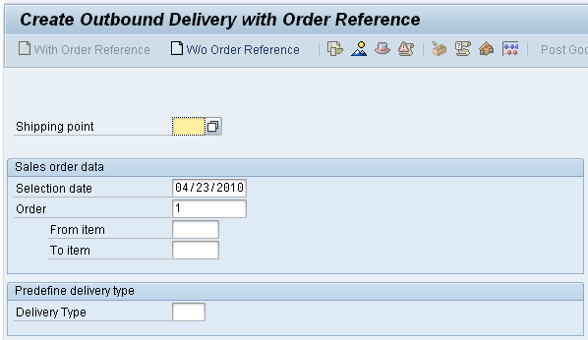
Look up possible Shipping points using the F4 help and select the GBI Shipping Point in Miami (MI00). Enter a selection date one week from today (you can use F4 to call up the calendar window). The sales order number should be entered automatically. Then click on . |  | MI00  one week from today
Note If you have logged off the SAP system after creating the sales order, the sales order number will not be entered automatically. You can search for your sales order number using the F4 help in the Order field. Here, please use the Sales documents by customer tab. Enter Sales Organization UE00 and the Purchase order no. you had entered (###). |  | Sales document search  F4  UE00  ###
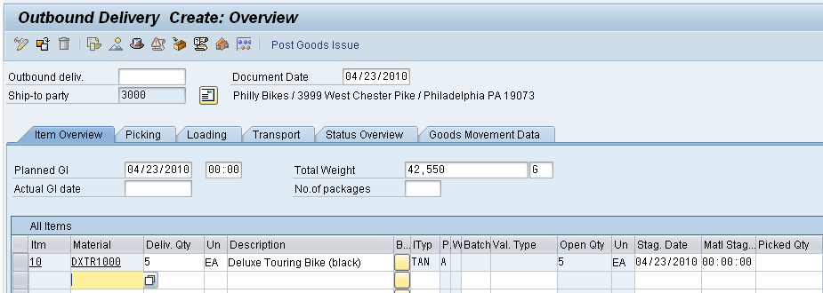
Notice that information from the sales order document has been copied into the new delivery document. Click on the save icon to create this document. In creating the delivery document, the SAP system performed a material availability check to make sure that the material was available to meet the customer’s required delivery date.  Once the delivery document has been created, materials management personnel in the warehouse can begin processing the sales order – picking, packing and shipping.  Note that the SAP system will assign a unique number for this new delivery document. This number will appear in a message at the lower-left corner of the screen. |  | Delivery document number
Click on the exit icon to return to the SAP Easy Access Menu.

 | SD 4: Pick Materials on Delivery Note
Exercise Use the SAP Easy Access Menu to pick materials. Time 10 min
Task The next step in the delivery process is to record the picking of the materials in the delivery document. Picking an order is the process of taking material from its storage location and moving it to a packing area. To record the picking of the material, we will actually make a change to the delivery document.
Name (Position) Sandeep Das (Warehouse Supervisor)
In order to create a sales order, follow the SAP Easy Access menu path:  Logistics ► Sales and Distribution ► Shipping and Transportation ► Outbound Delivery ► Change ► Single Document |  | Menu path
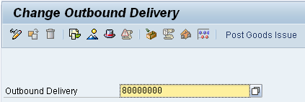
The Outbound Delivery document number should be entered automatically. Click on .
Note If you have logged off the SAP system after creating the delivery document, the delivery document number will not be entered automatically. You can search for your delivery document using the F4 help in the Outbound Delivery field. Here, please use the Outbound Delivery: Not Posted for Goods Issue tab. You can use the Shipping Point MI00 and your customer (3###) as search criteria. |  | Delivery document search  F4  MI00  3###
To enter the picked quantity, click on the Picking tab, which will produce the following.
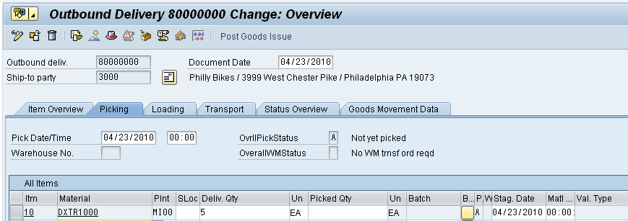
In this case, the storage location providing the picked materials is not automatically retrieved by the system. Please use the F4 key in the SLoc field to find and select the Finished Goods storage (FG00). In addition, you need to enter 5 for the picked quantity. |  | F4  FG00  5
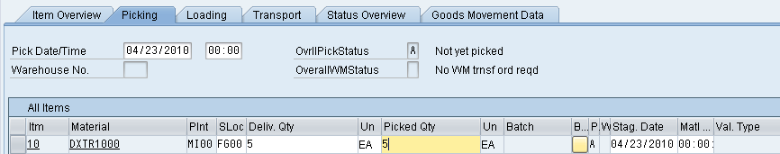
Then, click on to save the picking information. You should get the following message at the bottom-left corner of the screen. |  | Delivery document number
Click on the exit icon to return to the SAP Easy Access Menu.

 | SD 5: Post Goods Issue
Exercise Use the SAP Easy Access Menu to post a goods issue. Time 5 min
Task Posting the goods issue reduces unrestricted stock (material available to sell to customers) to reflect the inventory shipped – an inventory control function. In addition, legal ownership of the goods changes hands from you to the customer as the goods leave the plant (FOB shipping point) or when the goods are received by the customer (FOB destination). From an accounting perspective, both inventory and costs of goods sold are impacted by this transaction. The system reflects that the materials are no longer available in stock regardless of the shipping terms.
Name (Position) Sandeep Das (Warehouse Supervisor)
Posting the goods issue is another change to the delivery document. To do this, follow the menu path:  Logistics ► Sales and Distribution ► Shipping and Transportation ► Outbound Delivery ► Change ► Single Document  This will produce the following screen. |  | Menu path
Confirm that the delivery document number is entered, then click on the Post Goods Issue icon. You should get the following message at the bottom-left corner of the screen. |  | Post goods issue
Click on the exit icon to return to the SAP Easy Access Menu.

 | SD 6: Create Billing Document for Customer
Exercise Use the SAP Easy Access Menu to create a billing document. Time 5 min
Task Now that the bikes are being shipped to the customer, it is important to invoice the customer for the bikes so that payment can be received.
Name (Position) Stephanie Bernard (Billing Clerk)
To do this, follow the menu path:  Logistics ► Sales and Distribution ► Billing ► Billing Document ► Process Billing Due List  This will produce the following screen. |  | Menu path
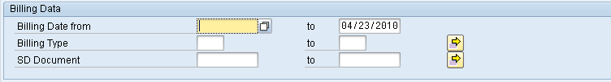
After specifying GBI’s Sales Organization for US East (UE00) and your customer (3###) as Sold-To Party (remember to replace ### with your three-digit number), click on the Display Bill List button. This will produce the following screen. |  | UE00  3###
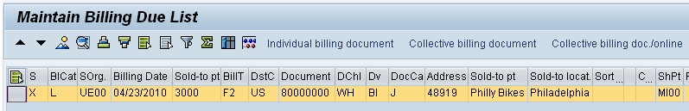
Click on the Collective billing document icon. The system will indicate that the invoice has been created by turning the highlight off on the delivery line.
Click on the exit icon twice to return to the SAP Easy Access Screen. |  | Delivery document number

 | SD 7: Post Receipt for Customer Payment
Exercise Use the SAP Easy Access Menu to post a customer payment. Time 10 min
Task We assume that our customer, Philly Bikes, has mailed us the payment for the bike order in the form of a check. Before we deposit the customer’s check, we need to record the receipt of this payment.
Name (Position) Jamie Shamblin (Cost Accountant)
To do this, follow the menu path:  Accounting ► Financial Accounting ► Accounts Receivable ► Document Entry ► Incoming Payments  This will produce the following screen. |  | Menu path
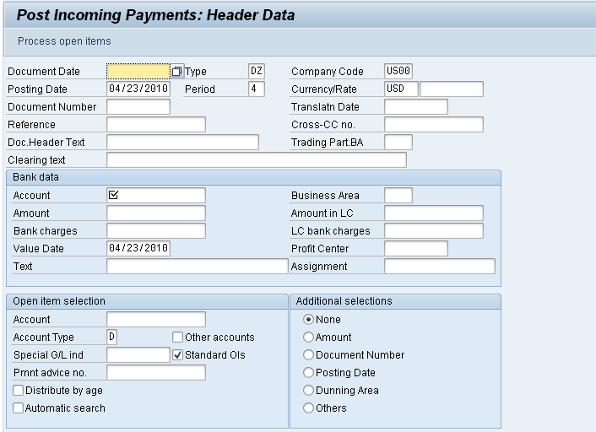
Use the F4 function key to enter the current date for the Document Date. Then enter:  US00 for Company Code USD for Currency/Rate  100000 for Account (Bank data) 15000 for Amount  Under Open item selection, please click in the Account field and then on the search icon or F4. In order to find your customer number for Philly Bikes (3###), you may use several criteria. The screenshot below shows an example search by Search term and City. |  | F4  US00  USD  100000  15000  3###
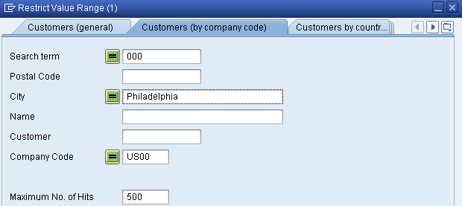 |  | Customer search
After clicking on to display the result list, double-click on Philly Bikes (customer number 3###) to select it. |  | 3###
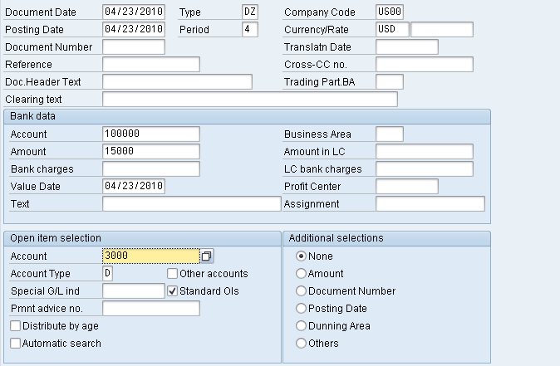
After clicking on Process open items, you will get the following screen. |  | Open items
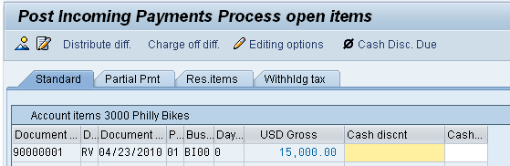
If the 15000 amount is not displayed in blue you may need to double-click on it to assign the payment to the accounts receivable. Confirm that the Not assigned field on the bottom of the screen is balanced (USD 0).
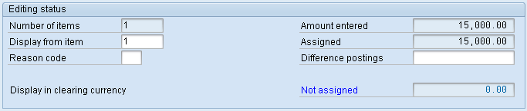
Note: Customers may have more than one invoice that must be paid, and may send a check that will cover more than one invoice, so this screen facilitates applying payments to more than one invoice. |  | Combined payments
After assigning the payment to the invoice, click on the save icon to post the payment. You should get the following message at the bottom-left corner of the screen.
Click on the exit icon .
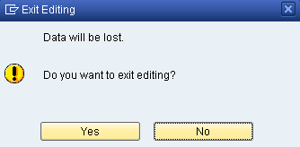
There is no data to be lost, so click on the Yes icon to return to the SAP Easy Access menu.

 | SD 8: Review Document Flow
Exercise Use the SAP Easy Access Menu to review the document flow. Time 15 min
Task There are many ways to access the document flow tool. One way is to start by displaying the sales order document.
Name (Position) David Lopez (East Rep. Miami)
SAP provides the Document Flow tool that tracks the entire sales transaction process from beginning to end. The Document Flow tool is extremely powerful because it can be used at any point in the sales order process. It provides an audit trail of all of the documents within the order cycle. Further, any of the referenced documents can be recalled and easily reviewed in detail (drilling down) from the document flow. |  | Document flow
To display the sales order document, follow the menu path:  Logistics ► Sales and Distribution ► Sales ► Order ► Display  This will produce the following screen. |  | Menu path
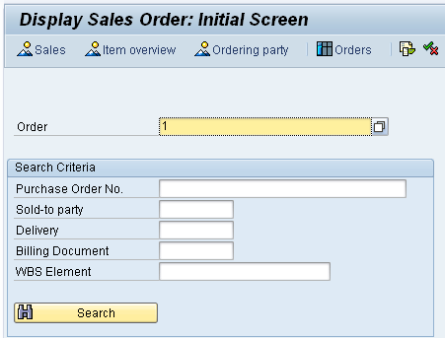
Your sales order number should be entered by default.
Note If you log off the SAP system after creating the sales order, the sales order number will not be entered automatically. You can search for you sales order number using the Sales documents by customer tab. Enter sales organization UE00 and the Purchase order no. you had entered (###). |  | Sales document search  UE00  ###
To access the document flow tool, click on or follow the pull-down menu path:  Environment ► Display document flow |  | Document flow
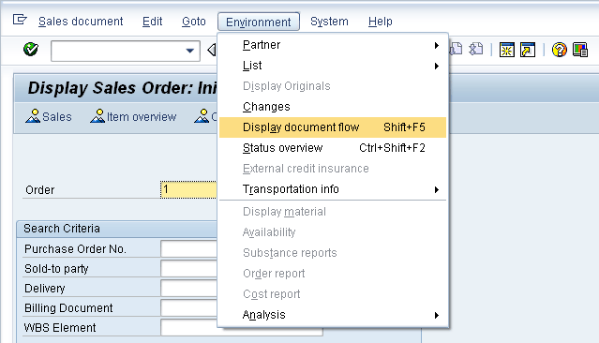
The document flow for the Philly Bike sales order will look like the following.
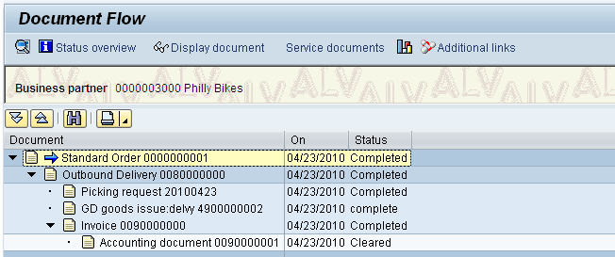
Any document can be accessed from the document flow. For example, to look at the invoice, click on the invoice line, then click on Display document. This should produce the following screen.
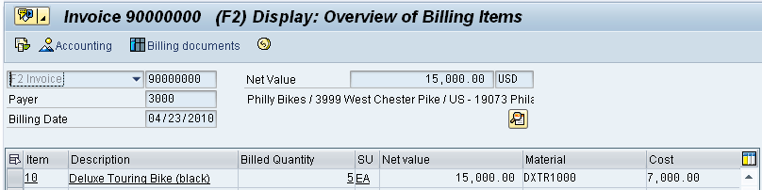
To access details of the invoice, follow the pull-down menu path:
Goto ► Header ► Header
This will produce the following screen.
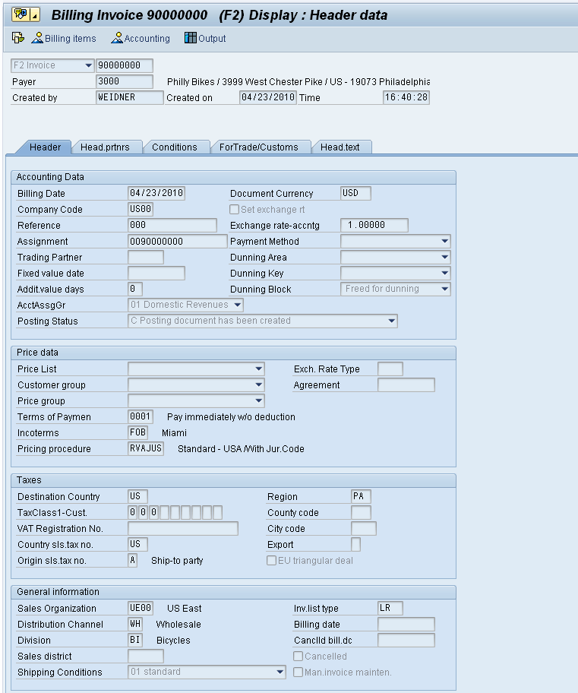
Note details of the invoice, like who created the invoice and when and the customer’s PO number.
Click on the exit icon to return to the document flow. Explore the document flow tool, then click on twice to return to the SAP Easy Access screen.

